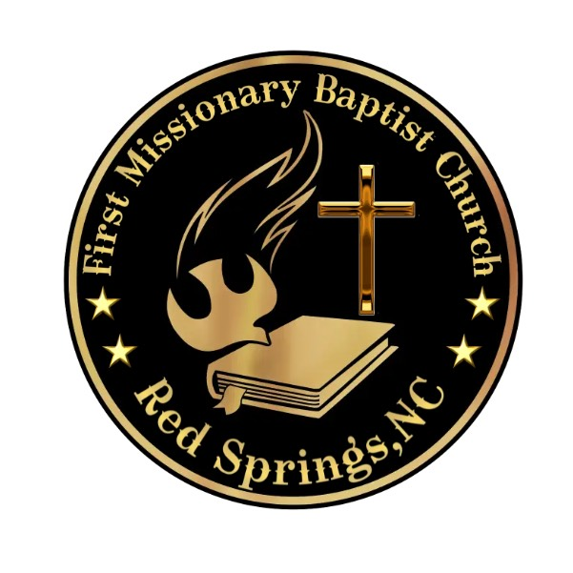
Frist Missionary Baptist Church, Red Springs, NC
Seven Days
Fasting & Prayer

Purpose
1) Humble ourselves, 2) Draw closer to God, 3) Seek a clearer understanding of
God’s Word, 4) Pursue God’s will for our lives, 5) Seek healing and wholeness of
God, and 6) Intercede and pray on behalf of others.

Date Event
Sun. 1/22/23 Fasting & Prayer, Bible Study
Mon. 1/23/23 Fasting & Prayer, Bible Study
Tues. 1/24/23 Fasting & Prayer, Bible Study
Weds. 1/25/.23 Fasting & Prayer, Bible Study
Thurs. 1/26/23 Fasting & Prayer, Bible Study
Fri. 1/27/23 Fasting & Prayer, Bible Study
Sat. 1/28/23 Fasting & Prayer, Bible Study

Consecration Period
There will be 7 days of fasting and prayer. Each day, you should pray, read the
“Spiritual Food” and eat the foods listed in the Daniel Fast.
Date
Start: January 22, 2023, 5 pm - End: January 28, 2023, 5 pm
Prayer Focus
1. Thank & praise God for what He has already done.
2. Ask God for the outpouring of His spirit and spiritual growth.
a. More of God’s Word d. More of God’s Spirit
b. More of God’s Will e. More of God’s Favor
c. More of God’s Love f. More of God’s Wisdom
3. Ask God’s salvation, blessings, wisdom, and favor for FMBC RS, that it will be the church He seeks without spot nor wrinkle.
4. Ask God’s blessings and anointing upon the leaders of FMBC RS.
5. Ask God’s blessings upon the FMBC RS family.
(Healing, Deliverance, Breakthrough, and Success)
6. Ask God’s blessings upon the FMBC RS Ministries.
7. Ask God’s blessings upon Red Springs, Robeson (surrounding counties), North
Carolina, United States, and the World.
Form
A. We will follow the Daniel’s Fast. Foods that can be eaten are fruits,
vegetables, whole grains, legumes, nuts, and seeds. Drink plenty of water.
Foods that cannot be eaten are dairy, meat, sugar, sweeteners, yeast, refined and
processed foods, deep fried foods, and solid fats.
B. If you cannot fast from foods because of health reasons, you may also fast by
avoiding something that you enjoy, i.e... Telephone, TV, Radio, Music, Sports, etc.

(PLEASE DO NOT TAKE THE EASY ROUTE FOR LACK OF DISCPLINE; GOD SEE YOU!)

Spiritual Food
Your Mind
Day 1 Philippians 2:1-11; Romans 8:5-17; 1 Peter 1:13-25
Day 2 Colossians 3:1-17; 2 Timothy 1:1-7; 2 Corinthians 10:1-5; Philippians 4:4-8
Your Body
Day 3 2 Corinthians 4:7-18; 9 Philippians 3:12-21
Day 4 Romans 12:1-21; Ephesians 4:1-16; 1 Corinthians 6:12-20
Day 5 Matthew 6:25-34; Corinthians 9:22-27
Your Spiritual Soul
Day 6 Psalm 63; 1 Thessalonians 5:16-24; Hebrews 10:32-39; 1 Peter 2:1-12
Day 7 Galatians 5:16-26; Matthew 4:1-11; Revelation 22:1-5
DAY 1 - PREPARATION
Our annual Consecration and Fasting season will start on Sunday, January 22 5 pm and
will conclude on Saturday, January, 5 pm. Please begin to make preparation for this season
as we seek God through fasting and prayer. For the week we will publish healthy
eating habits and recipes to help you successfully complete the fast for 7 days! Each week will
include healthy eating tips and suggestions.
Getting Started:
Make a weekly shopping LIST from the approved food list on the church website https://www.firstmissionarybaptistrs.org/) and use while grocery
Shopping. PLAN your meals. Meal planning is one of the most important things you can do to
ensure your success during the fast. The key is to set aside some time each day to do
meal planning. Determine which meals you plan to prepare and cook for couple of days
or the entire week. Make one day a week dedicated to grocery shopping and meal
planning. A few snacks suggestions include fresh fruit, popcorn (topped
with olive oil and lightly salted), baked corn tortilla chips with hummus or salsa, celery,
carrots, cucumbers, broccoli, or nuts. Drink WATER ONLY. Drink at least eight glasses of water (64 ounces) per day.

